**AI POWERED ARTICLE ANALYSIS AND RECOMMENDATION**

**Team: Phantom**

# Step 1: Problem Statement

This project is about building a smart system that can work with a collection of Medium articles.

The main objective is to understand what each article is about, group similar articles together, suggest the right tags for them, and figure out which articles might get more attention. This involves analyzing the article content, identifying key patterns in how they are written and tagged, and using that information to make intelligent recommendations.

# Step 2: Importing the Necessary Libraries

*# Basic libraries for data anipulation*

import pandas as pd import numpy as np import ast

*# Visualization libraries* import matplotlib.pyplot as plt import seaborn as sns

*# For Text Preprocessing*

import re import nltk

from nltk.corpus import stopwords

from nltk.stem import WordNetLemmatizer from nltk.tokenize import word_tokenize from collections import Counter

from wordcloud import WordCloud

from sklearn.feature_extraction.text import CountVectorizer

*# Initialize lemmatizer and stopwords*

lemmatizer = WordNetLemmatizer()

stop_words = set(stopwords.words('english'))

*# Ignore warnings for better readability* import warnings warnings.filterwarnings('ignore')

*# Set a visual style*

sns.set_style("whitegrid")

* Step 3: Loading the Dataset

file_path = "/kaggle/input/medium-article-dataset/AI-Powered Content Analysis and Recommendation.csv"

*# Load the dataset*

df = pd.read_csv(file_path)

*# Preview of the data*

0

1

2

3

4

text Photo by Josh Riemer on Unsplash\n\nMerry Chri... Your Brain On Coronavirus\n\nA guide to the cu... Mind Your Nose\n\nHow smell training can chang... Passionate about the synergy between science a... You’ve heard of him, haven’t you? Phineas Gage...

\

df.head()

title \

1. Mental Note Vol. 24
2. Your Brain On Coronavirus
3. Mind Your Nose
4. The 4 Purposes of Dreams
5. Surviving a Rod Through the Head

url

authors \

1. https://medium.com/invisible-illness/mental-no... ['Ryan Fan']
2. https://medium.com/age-of-awareness/how-the-pa... ['Simon Spichak']
3. https://medium.com/neodotlife/mind-your-nose-f... []
4. https://medium.com/science-for-real/the-4-purp... ['Eshan Samaranayake']
5. https://medium.com/live-your-life-on-purpose/s... ['Rishav Sinha']

timestamp \

0 2020-12-26 03:38:10.479000+00:00

1 2020-09-23 22:10:17.126000+00:00

2 2020-10-10 20:17:37.132000+00:00

3 2020-12-21 16:05:19.524000+00:00

4 2020-02-26 00:01:01.576000+00:00

tags

1. ['Mental Health', 'Health', 'Psychology', 'Sci...
2. ['Mental Health', 'Coronavirus', 'Science', 'P...
3. ['Biotechnology', 'Neuroscience', 'Brain', 'We...
4. ['Health', 'Neuroscience', 'Mental Health', 'P...
5. ['Brain', 'Health', 'Development', 'Psychology...

*The dataset consists of six features: title, text, URLs, authors, timestamp, and tags. The 'authors' and 'tags' columns are in list format, while the remaining columns are in text format. This is a well-structured dataset suitable for achieving the goals of this project*

# Step 4: Exploring the Data

count unique top freq

text 192368

185474

Learn more. Medium is an open platform where 1...

1976

\

*# Summary of the data*

df.describe()

title \

count 192363

unique 187892

top by Martino Pietropoli freq 93

*# No of rows & columns*

df.shape

(192368, 6)

*The dataset consists of 19,236 rows and 6 columns. Using info(), we can observe the count of non-null values in each column along with their data types*

*# Get basic information about the data*

df.info()

<class 'pandas.core.frame.DataFrame'> RangeIndex: 192368 entries, 0 to 192367 Data columns (total 6 columns):

# Column Non-Null Count Dtype

1. title 192363 non-null object
2. text 192368 non-null object
3. url 192368 non-null object
4. authors 192368 non-null object
5. timestamp 192366 non-null object
6. tags 192368 non-null object dtypes: object(6)

memory usage: 8.8+ MB

*The describe() function provides information such as the number of entries, unique values, the most frequent value, and its frequency.*

|  |  |  |
| --- | --- | --- |
|  | url | authors \ |
| count | 192368 | 192368 |
| unique | 192368 | 83915 |
| top | https://medium.com/invisible-illness/mental-no... | [] |
| freq | 1 | 30955 |

|  |  |  |
| --- | --- | --- |
|  | timestamp | tags |
| count | 192366 | 192368 |
| unique | 191612 | 183380 |
| top | 2019-03-13 14:21:44.055000+00:00 | ['Startup'] |
| freq | 22 | 80 |

From the output, we can infer that the 'authors' column often contains empty lists, indicating missing author names for many articles. Also, each URL appears only once, confirming that all URLs are unique.

# Step 5: Datatype Conversion

*# Convert timestamp to datetime*

df['timestamp'] = pd.to_datetime(df['timestamp'], errors='coerce')

*# Convert authors & tags from String to List*

df['authors'] = df['authors'].apply(lambda x: ast.literal_eval(x) if isinstance(x, str) else x)

df['tags'] = df['tags'].apply(lambda x: ast.literal_eval(x) if isinstance(x, str) else x)

*The data type of the 'timestamp' column is converted to datetime format to enable time-based analysis. The 'authors' and 'tags' columns are converted from string to list format for future use in tag modeling and author analysis.*

# Step 6: Cleaning the Data

*Used isnull() to identify missing values in the dataset.*

*# Check for nulls*

df.isnull().sum()

|  |  |
| --- | --- |
| title | 5 |
| text | 0 |
| url | 0 |
| authors | 0 |
| timestamp | 413 |
| tags | 0 |
| dtype: int64 |  |

From the output, only the 'title' and 'timestamp' columns have missing values, with counts of 5 and 413 respectively. These will be handled by removing the corresponding rows from the dataset.

Since these columns are important for future analysis, imputing them may not be reliable. Additionally, the number of missing rows is less than 1% of the dataset, so their removal will not significantly impact the data.

*# Drop rows with missing title, text or timestamp*

df = df.dropna(subset=['title', 'text','timestamp'])

*Identify empty entries in the 'authors' and 'tags' columns and replace them with "Unknown" and "Untagged" respectively*

*# Count empty lists in authors*

empty_authors_count = df['authors'].apply(lambda x: len(x) == 0).sum()

*# Count empty lists in tags*

empty_tags_count = df['tags'].apply(lambda x: len(x) == 0).sum()

print(f"Empty lists in 'authors': {empty_authors_count}") print(f"Empty lists in 'tags': {empty_tags_count}")

Empty lists in 'authors': 30858 Empty lists in 'tags': 0

*# Replace empty authors with Unknown and empty tags with Untagged* df['authors'] = df['authors'].apply(lambda x: ["Unknown"] if not x else x)

df['tags'] = df['tags'].apply(lambda x: ["Untagged"] if not x else x)

*Visualizing part of data before cleaning*

0

1

2

3

4

text Photo by Josh Riemer on Unsplash\n\nMerry Chri... Your Brain On Coronavirus\n\nA guide to the cu... Mind Your Nose\n\nHow smell training can chang... Passionate about the synergy between science a... You’ve heard of him, haven’t you? Phineas Gage...

\

df.head()

title \

url

authors \

1. https://medium.com/invisible-illness/mental-no... [Ryan Fan]
2. https://medium.com/age-of-awareness/how-the-pa... [Simon Spichak]
3. https://medium.com/neodotlife/mind-your-nose-f... [Unknown]
4. Mental Note Vol. 24
5. Your Brain On Coronavirus
6. Mind Your Nose
7. The 4 Purposes of Dreams
8. Surviving a Rod Through the Head
9. https://medium.com/science-for-real/the-4-purp... [Eshan Samaranayake]
10. https://medium.com/live-your-life-on-purpose/s... [Rishav Sinha]

timestamp \

0 2020-12-26 03:38:10.479000+00:00

1 2020-09-23 22:10:17.126000+00:00

2 2020-10-10 20:17:37.132000+00:00

3 2020-12-21 16:05:19.524000+00:00

4 2020-02-26 00:01:01.576000+00:00

tags

1. [Mental Health, Health, Psychology, Science, N...
2. [Mental Health, Coronavirus, Science, Psycholo...
3. [Biotechnology, Neuroscience, Brain, Wellness,...
4. [Health, Neuroscience, Mental Health, Psycholo...
5. [Brain, Health, Development, Psychology, Science]

*We used the clean_text function to clean the data by converting it to lowercase, removing special characters, extra whitespace, and URLs.*

*# Function to clean text*

def clean_text(text):

if not isinstance(text, str): return ""

*# Convert to lowercase*

text = text.lower()

*# Remove HTML tags*

text = re.sub(r'<.*?>', '', text)

*# Remove URLs*

text = re.sub(r'http\S+|www\S+|https\S+', '', text)

*# Remove special characters and numbers*

text = re.sub(r'[^a-zA-Z\s]', '', text)

*# Remove extra whitespace*

text = re.sub(r'\s+', ' ', text).strip() return text

*# Apply basic cleaning to title and text*

df['clean_title'] = df['title'].apply(clean_text) df['clean_text'] = df['text'].apply(clean_text)

# Step 7: Data Preprocessing Text Data

*# !unzip /usr/share/nltk_data/corpora/wordnet.zip -d*

*/usr/share/nltk_data/corpora/*

*The next step is to preprocess the text data by applying tokenization, lemmatization, and removing stop words to prepare it for further analysis and modeling.*

* + Tokenization: Breaking text into individual words or terms. Example: "AI is powerful" → ["AI", "is", "powerful"]
  + Lemmatization: Reducing words to their base or dictionary form. Example: "running", "ran", "runs" → "run"
  + Stop Words: Commonly used words that are often removed in NLP tasks. Example: "is", "the", "and", "in"

*# Function for tokenization and lemmatization*

def tokenize_and_lemmatize(text):

*# Tokenize*

tokens = word_tokenize(text)

*# Remove stopwords and lemmatize*

tokens = [lemmatizer.lemmatize(word) for word in tokens if word not in stop_words]

return tokens

*# Apply tokenization and lemmatization* df['tokenized_title'] = df['clean_title'].apply(tokenize_and_lemmatize)

df['tokenized_text'] = df['clean_text'].apply(tokenize_and_lemmatize)

# Step 8: Exploratory Data Analysis (EDA)

*Start with, Word count/text length analysis*

*# Length by word count*

df['article_length'] = df['tokenized_text'].apply(len)

plt.figure(figsize=(10, 5)) sns.histplot(df['article_length'], bins=50, kde=True) plt.title('Article Length Distribution') plt.xlabel('Number of Words')

plt.ylabel('Number of Articles') plt.show()

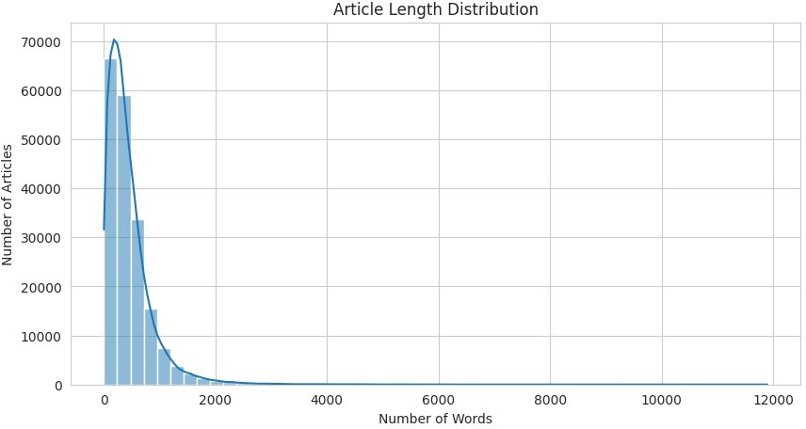

📌Insight: Most articles are under 1,000 words, with all articles being below ~2,500 words. The distribution peaks on the left, indicating that shorter articles are more common than longer ones

*Identify and display the most common tags (top 20)*

from collections import Counter

*# Flatten list of all tags*

all_tags = [tag for tags in df['tags'] for tag in tags] tag_counts = Counter(all_tags)

*# Convert to DataFrame*

top_n = 20

tag_df = pd.DataFrame(tag_counts.most_common(top_n), columns=['Tag', 'Count'])

plt.figure(figsize=(12, 6))

sns.barplot(data=tag_df, x='Count', y='Tag', palette='viridis') plt.title(f'Top {top_n} Most Common Tags')

plt.xlabel('Count') plt.ylabel('Tag') plt.show()

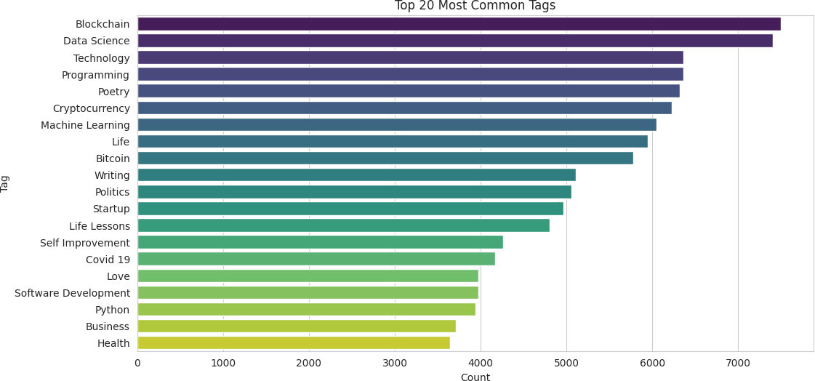

📌Insight: Blockchain, Data Science, and Technology are the most common tags in the dataset, indicating that a majority of the articles are related to tech content.

*Identifying tag count per article*

df['num_tags'] = df['tags'].apply(len)

plt.figure(figsize=(10, 5)) sns.histplot(df['num_tags'], bins=20, kde=False) plt.title('Tag Count per Article') plt.xlabel('Number of Tags')

plt.ylabel('Number of Articles') plt.show()

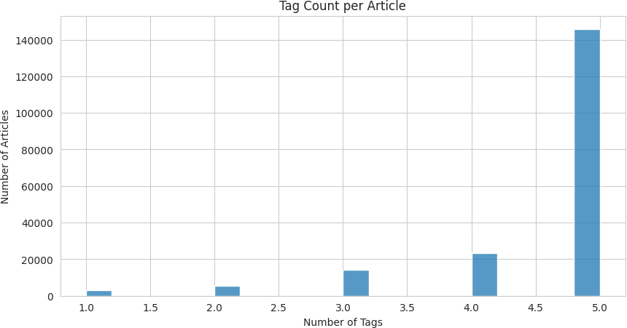

📌Insight: The majority of articles have 5 tags, and the article count decreases with fewer tags. This suggests that authors commonly use 5 tags, which can be useful for building a tag recommendation system

*Identify and display top 20 authors with most articles*

*# Flatten list of authors*

all_authors = [author for authors in df['authors'] for author in authors]

author_counts = Counter(all_authors)

*# DataFrame for top authors*

top_n = 20

author_df = pd.DataFrame(author_counts.most_common(top_n), columns=['Author', 'Articles'])

plt.figure(figsize=(12, 6))

sns.barplot(data=author_df, x='Articles', y='Author', palette='mako') plt.title(f'Top {top_n} Authors by Article Count') plt.xlabel('Articles')

plt.ylabel('Author') plt.show()

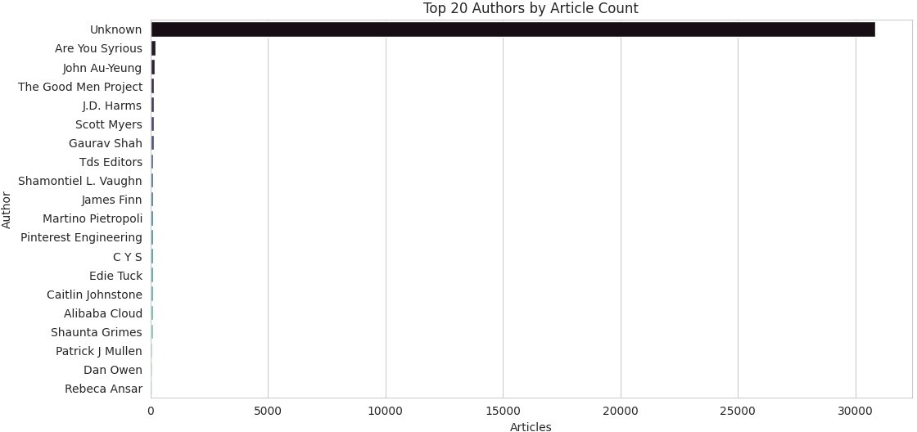

* Insight: As observed earlier, the count of empty lists in the 'authors' column is high. This is reflected here as well, where "Unknown" authors appear most frequently, while all other authors have significantly lower counts

*Identify articles published in different days of the week*

df['weekday'] = df['timestamp'].dt.day_name()

plt.figure(figsize=(10, 5))

order = ['Monday', 'Tuesday', 'Wednesday', 'Thursday', 'Friday', 'Saturday', 'Sunday']

sns.countplot(x='weekday', data=df, order=order, palette='flare') plt.title('Articles Published by Day of the Week') plt.xlabel('Day')

plt.ylabel('Number of Articles') plt.xticks(rotation=45) plt.show()

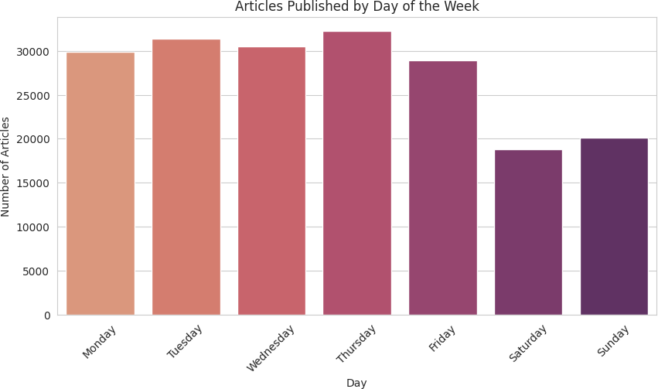

* Insight: Most articles are published at the start of the week, indicating that authors are more active in posting articles during that time